**COMPETITION 65691 (Econ 27): January 27, 2020**

**PART 1** (relevant code in R can be found in the file ‘written assignment 1.ipynb’ )

1. How many clients have participated in the OAT program? 44,200.
2. What is the client count, by drug, and year?

Table 1. Clients by drug type, and year

(where A=methadone, B=nalaxone, C=morphine)

|  |  |  |  |
| --- | --- | --- | --- |
| Year | A | B | C |
| 2003 | 1064 | na | na |
| 2004 | 2253 | na | na |
| 2005 | 3139 | na | na |
| 2006 | 4122 | na | na |
| 2007 | 5143 | 9 | na |
| 2008 | 5952 | 208 | na |
| 2009 | 6940 | 512 | na |
| 2010 | 8267 | 877 | na |
| 2011 | 9712 | 1317 | na |
| 2012 | 11153 | 1825 | na |
| 2013 | 12294 | 2243 | na |
| 2014 | 13613 | 2666 | na |
| 2015 | 14924 | 3110 | na |
| 2016 | 16169 | 5069 | na |
| 2017 | 17476 | 7784 | 137 |
| 2018 | 18748 | 9181 | 395 |

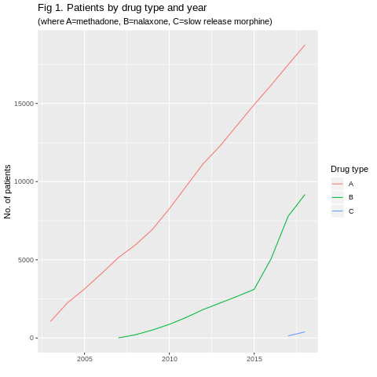

1. Did the policy changes in October 2015 and July 2016 affect the client counts?

* Visually, both policies appear to increase the number of clients (Fig 2). However, only the October 2015 policy appears to be significant.
* To test the Oct 2015 significance, I created the monthly ‘difference’ variable[1] of the number of patients taking naloxone. The ‘difference’ variable was divided into two: (1) number of clients before Oct 2015, and (2) clients after Oct 2015 but before July 2016. The increase in clients taking naloxone following the 2015 policy has a significant t-statistic (t = -5.5707, df = 8.2738, p-value = 0.0004687)
* To test the July 2016 policy, the ‘difference’ variable was again divided into two: (1) number of clients taking naloxone after Oct 2015 but before July 2016 , and (2) clients taking naloxone after July 2016. The increase in clients taking naloxone following the 2015 policy is not significant (t = -1.8715, df = 20.104, p-value = 0.0759)

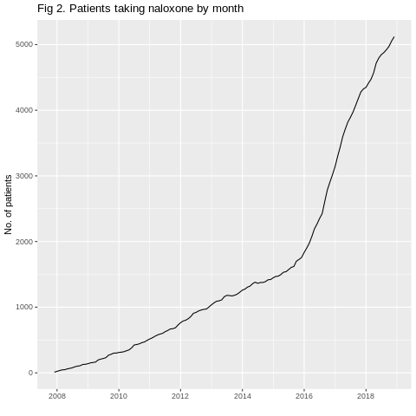

**PART 2** (relevant R code can be found in file ‘written assignment 2.ipynb’ )

**BACKGROUND:** Fundamentals of time series data

The sequential nature of time series data may have the following implications on modelling and forecasting[2]. Observations from previous (lagged) time periods may help predict observations of subsequent periods. Such time series data are said to violate the property of stationairty[3]. These data may contain the following properties, which can be identified and used to coerce them into stationarity for modelling:

* Autoregression is when observations of previous time periods help predict observations of subsequent periods. For example, observation y(t- p) from p lagged periods may predict future y(t). A projection model that fits the data is an autoregressive (**AR**) model of order **p**.
* Moving average is when the shocks from residuals of previous time periods help predict observations of future periods. Here, residual e(t-q) from lagged period q may predict future e(t) and y(t). A model that fits this data is a moving average (**MA**) model is of order **q**.
* ARIMA models put together both AR and MA properties.

**ASSUMPTIONS:**

Variables that may predict community A’s data include: the health authority’s and community A’s client numbers and service volume data respectively, and the province’s total population .

**METHODOLOGY:**

1. The following observations are used to build historic variables, from 2012-2019: the health authority’s and community’s client numbers and service volumes respectively, and the provincial population [4] .
2. The variables are used to estimate the following ratios for 2012-2019:

* Health authority’s clients as a share of total provincial population (a ratio I termed as ratio ‘**ha_p’** in my Excel spreadsheet)
* Community A’s clients as a share of the health authority’s clients (termed as ratio‘**a_ha’**)
* Service volume per client in Community A (termed as ratio ‘**a_n**’)

1. I estimate AR and MA orders for the above ratios. These orders help fit a model that projects the ratios into to 2020-2022. Ising the 2020-2022 ratios, I project client numbers and service volumes for 2020-2022 as follows:

* Provincial population (t) * ha_p ratio (t) = health authority clients (t).
* Health authority’s clients (t) * a_ha ratio (t) = community A’s clients (t)
* Community A’s clients (t) * a_n ratio (t) = community A’s service volume

**RESULTS:**

What follows is an illustrative example for estimating one of the ratios (ha_p) for 2012-2019. As well, this estimatesAR and MA orders; and the ratios for 2020-2022 (code is in file ‘part2.ipynb’).

* Between 2012-2019, the ha_p ratio increased in a linear fashion, with AR of order 1 (p =1) and MA of order 2 (q=2), shown in Fig1 (left).
* On Fig 1 (right), I fit p and q to a projection for 2020-2022 (p=1, d=0, q=2). Here, d =0, because ‘ha_p’ increased in a linear fashion, with no difference ‘d’ variable needed [5].
* As described in the methodology, together with the remaining ratios, I project community A’s client numbers and service volumes (Table 1). The Excel spreadsheet contains the remaining ratios, AR and MA orders used for projecting client numbers and service volumes ( Table 1.)

Fig 1. AR and MA orders (left); fitted model (right) for ‘ha_p’

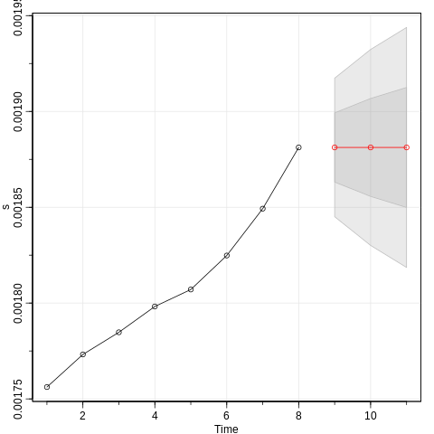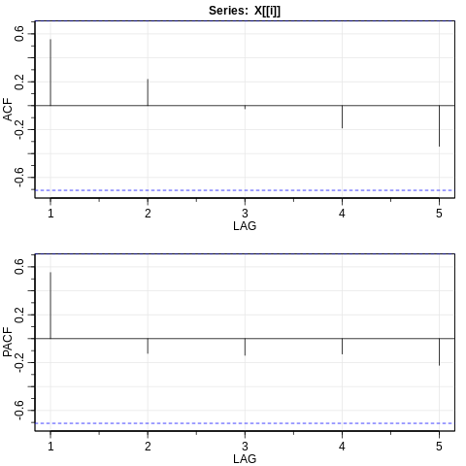

Table 1. Forecast clients and service hours for community A

|  |  |  |  |  |
| --- | --- | --- | --- | --- |
| Year | Clients | Service vol. | Grwth % a | Funding grth%b |
| 2020 | 1839 | 30,090 | 2 | 2 |
| 2021 | 1861 | 30,318 | 1 | 2 |
| 2022 | 1879 | 30,558 | 1 | 2 |

‘a’ -growth rate is the same for clients and service volume; ‘b’-health authority funding growth

**CONCLUSION**

* Community A’s number of clients and service hours are predicted using their own and the health authority’s lagged data, and provincial populations.
* Community A’s projected growth rate in client numbers and service hours is between 1-2 per cent, which is less than the health authority’s estimates (2%.)

**LIMITATIONS**

* The discrepancy with the health authority’s growth estimates maybe partly due to errors in my R code. Errors in my code prevent me from estimating AR and MA orders for the ‘difference’ of ratios/variables .
* Errors also prevent me from estimating the residuals, related to the AR and MA orders. Having the residuals would lead to a better model fit.

1. A difference variable is estimated by subtracting one lagged observation.
2. Econometrics by Erasmus University, Rotterdam accessed on Coursera.
3. Stationary time series variables have constant mean, variance and covariance with residuals over time.
4. Obtained from ‘B.C. Stats population projection’ <<https://bcstats.shinyapps.io/popProjApp/>>
5. For example, a difference of 1 is estimated by subtracting one lagged observation.